
To make sure we can find a solution for your project, we need following data from you.
Name and adress

Identifier customer needs
Company name
Address
city
your e-mail
telephone number
collegues you want to keep in the loop
name e mail job title

Material Description: (Expected Range)
Finishing: | Yes, what type of finish?  Belt Brush Hairline | No
Calibrating (make to size): | Yes | No
Material type:
Length: | Min: | Max:
Width: | Min: | Max:
Thickness: | Min: | Max:
Stock removal: | Total: | Both sides: yes/no
Tolerance: | Neg: | Pos
Roughness: | Ra: | Rz
Alpha Case removal: | Yes | No

Please indicate the number of sheets or plates or pieces you need to grind annually. In order to adapt our proposal as close as possible to your production needs, can you tell us the average size or quantities per size (appr.)?

Production
Average | Length | Quantity
Short plates | Length | Quantity
Long plates | Length | Quantity
Number of shifts

The Machine Line
Please describe your ideal machine line. Please tick the box if you would like to receive more information about:
Handling Equipment: (pick and placers) |  | 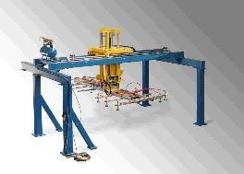
Handling Equipment: (turnover device) |  | 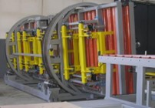
Handling Equipment: (flipper) |  | 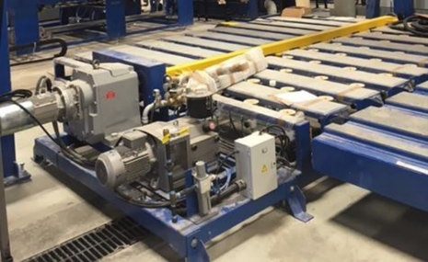
Handling Equipment: (roller table) |  | 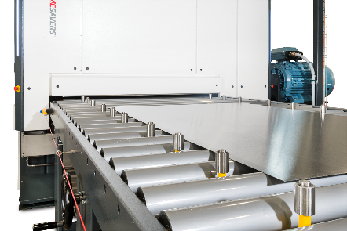
Washer |  | 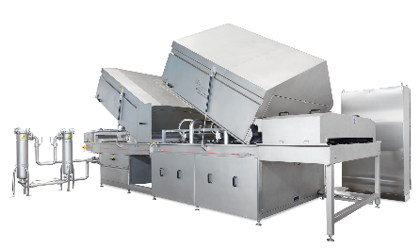
PVC Coating |  | 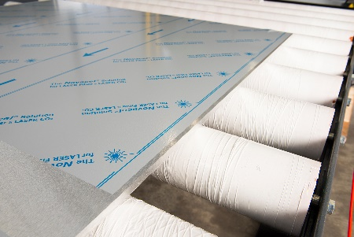
Measuring |  | 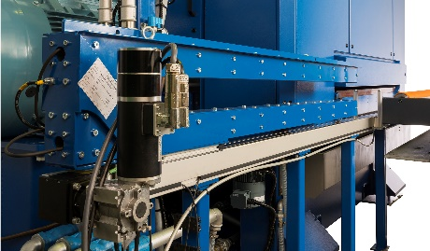

Questions? Comments?

Thank you for sharing this information with us. We now have enough material to start with a first quote! Once you´re done, please share this with:

Exciting times ahead!
Project leader: Piet Kooman, e-mail: pkooman@timesaversint.com

